
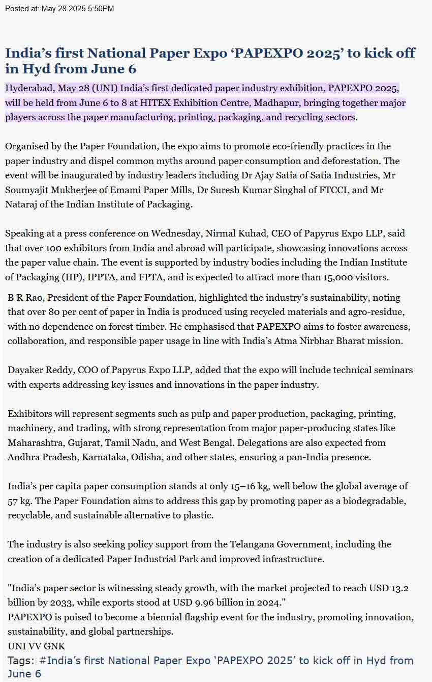
https://www.uniindia.com/india-s-first-national-paper-expo-papexpo-2025-to-kick-off-in-hyd-from-june-6/south/news/3475768.html#:~:text=Hyderabad%2C%20May%2028%20(UNI),%2C%20packaging%2C%20and%20recycling%20sectors

