

India’s First-Ever National Paper Expo, PAPEXPO
2025, To Debut In Hyderabad From June 6–8.

tripurastarnews30 May 28, 2025 7 min read

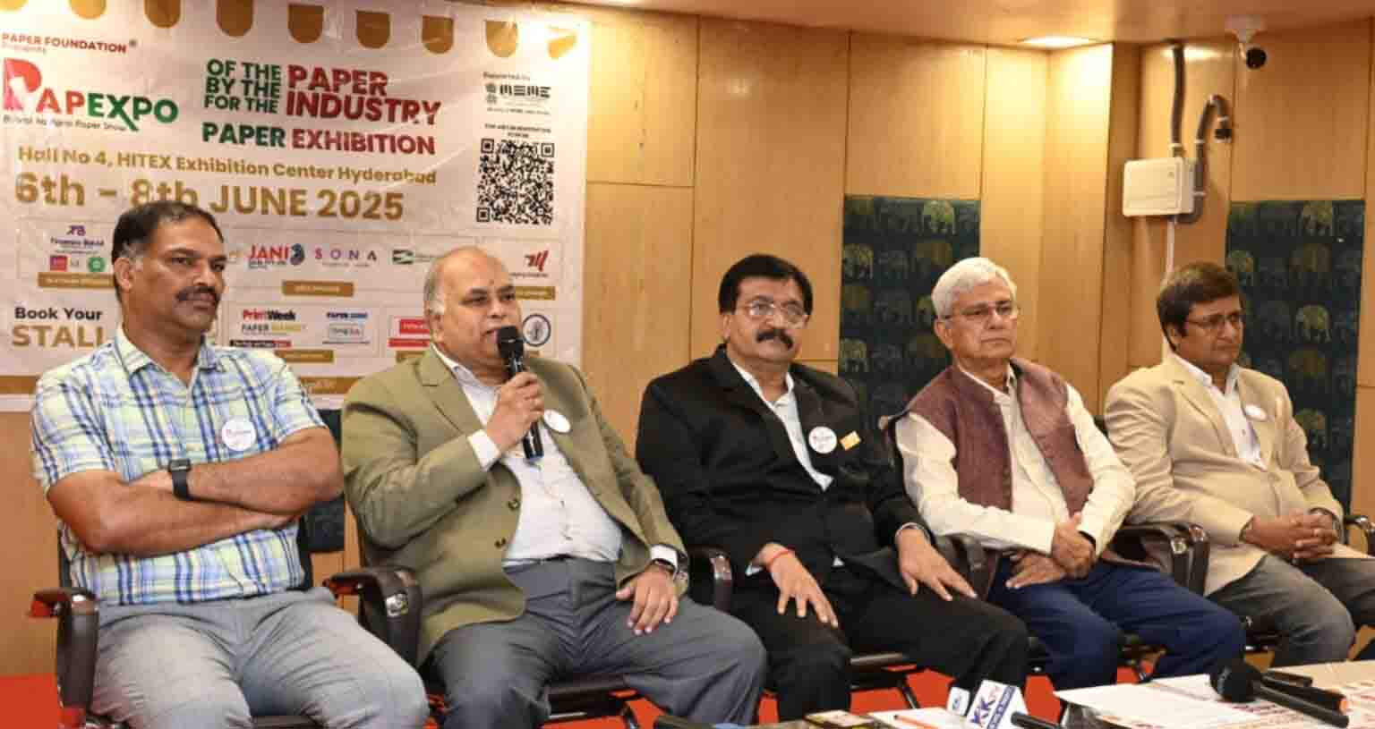
Hyderabad, Telangana, 28th of May, 2025 : The Paper Foundation is set to host PAPEXPO 2025, India’s first dedicated exhibition for the paper industry, from June 6 to 8, 2025, at HITEX Exhibition Centre, Hyderabad. This landmark three-day event will bring together the entire value chain of India’s paper industry under one roof, making it one of the largest and most comprehensive industry gatherings in the country.

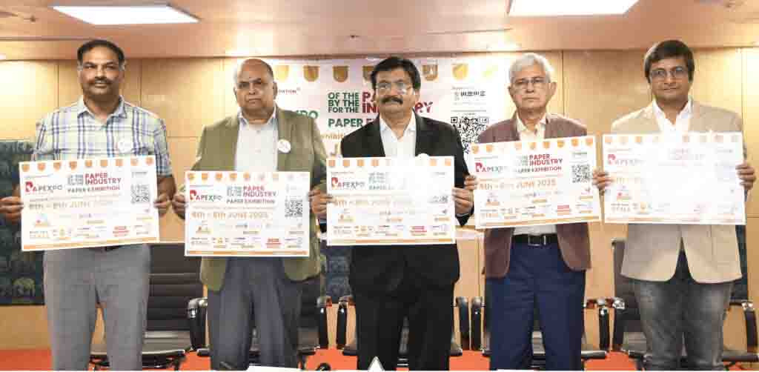
(L-R) Mr Dayaker Reddy, COO, Papyrus Expo LLP; Mr B R Rao, President, Paper Foundation & Director, Papyrus Expo LLP; Mr Nirmal Kuhad, CEO, Papyrus Expo LLP; Mr Arvind Sharma, Director, Papyrus Expo LLP & Mr Moolchand Parekh, Finance, Papyrus Expo LLP; holding a poster of the First edition of PAPEXPO 2025, to be hosted by Paper Foundation, an NGO, supported by Ministry of MSME, Govt. of India; today at a Press Conference, at The Plaza, Begumpet.
The eminent Guests of Honour who will inaugurate the exhibition on June 6 at 10:00 AM, are Dr Ajay Satia, Md, Satia; Mr Soumyajit Mukherjee, Cmo, Emami Paper Mills; Mr Nataraj, Deputy Director, Iip; Dr Suresh Kumar Singhal, President, Ftcci; Mr Sohanlal Dayama, Prompt Packaging, Mr Rushabh Shah, Md, Three Paper Boards Ltd; Mr Abaili Jani, Director, Jaini Sales, will grace the occasion.
PAPEXPO is being supported by esteemed industry bodies including the Indian Institute of Packaging (IIP), Indian Pulp and Paper Technical Association (IPPTA), and the Federation of Paper Traders Associations of India (FPTA).
Over 100 national and international exhibitors will participate, showcasing the latest innovations and product offerings across paper manufacturing, converting, printing, packaging, and recycling. The Expo is expected to draw over 15,000 visitors over three days.
India’s top paper manufacturers, EMAMI PAPER, WEST COAST, SATIA INDUSTRIES, JANI SALES, SHAH PAPERS, THREE M PAPERS BOARD PVT LTD, PROMPT PACKAGING, VIJAYANAND SPECIALITY, CLASSIC PAPERS among others will showcase premium specialty paper, sustainable packaging solutions, eco-friendly innovations, and advanced printing technologies. Leading traders will also mark their presence, including TIRUMALA BALAJI PAPER PRIVATE LTD, HYPER PACK, SRI AYYAPPAN CO, MLM PACKAGING, SONA PAPERS, reinforcing PAPEXPO’s position as a must-attend event for stakeholders in the sector.
PAPEXPO is India’s very own dedicated paper industry showcase—a first-of-its-kind platform proudly hosted by Paper Foundation, an NGO we established to promote and uplift paper usage across the country. Despite being one of the fastest-growing economies, India still ranks among the lowest in per capita paper consumption. PAPEXPO aims to change that. Supported by the Ministry of MSME, Government of India, this exhibition is a significant step toward empowering small and medium enterprises (SMEs) in the sector. The event has garnered enthusiastic participation from all leading paper manufacturers, and is drawing visitors from neighbouring nations, including the Gulf region, reflecting its growing international relevance. A key focus of PAPEXPO is to dispel the long-standing myth that paper consumption contributes to deforestation. In reality, nearly 80% of the paper produced and used in India comes from recycled sources—making it one of the most sustainable industries in the country. Through this platform, we aim to highlight the eco-friendly evolution of paper and its vital role in sustainable development, says Mr Nirmal Kuhad.
Mr B R Rao (2nd from Left), President, Paper Foundation & Director, Papyrus Expo LLP; flanked by (L-R) Mr Dayaker Reddy, COO, Papyrus Expo LLP; Mr Nirmal Kuhad, CEO, Papyrus Expo LLP; Mr Arvind Sharma, Director, Papyrus Expo LLP & Mr Moolchand Parekh, Finance, Papyrus Expo LLP; briefing media about the First edition of PAPEXPO 2025, hosted by Paper Foundation, an NGO, supported by Ministry of MSME, Govt. of India; today at a Press Conference, at The Plaza, Begumpet.
Mr B R Rao, speaking on the occasion said, the newly formed Paper Foundation has been established with a clear and purposeful mission—to promote responsible paper usage, support India’s vision of Atmanirbhar Bharat, and encourage the adoption of domestically produced paper. The Foundation seeks to unite all stakeholders of the paper ecosystem on a single platform to foster collaboration, awareness, and innovation. A widespread myth that reducing paper usage saves trees has discouraged many from using this eco-friendly material. The truth, however, is quite the opposite. In India, 80% to 82% of paper is produced from recycled materials such as waste paper, agricultural residue, and sugarcane bagasse. The Indian paper industry does not contribute to deforestation; in fact, it operates without reliance on forest timber. Since 1965, the government has stopped allocating forest resources to the paper sector, and no new licenses have been issued for this purpose. For companies that were granted land allocations before 1965, strict regulations are in place, every tree harvested must be replaced by planting four more. These sustainable practices are closely monitored by the government, making the industry a net contributor to reforestation efforts rather than a threat to them. Moreover, the paper industry in India plays a vital role in recycling global waste. A significant portion of the country’s raw material comes from waste paper imported from countries like the USA, UK, and other developed nations, making India a key player in the circular economy and global environmental stewardship. The Foundation is also dedicated to advancing paper as an eco-friendly alternative to harmful materials, by encouraging and funding research, used in packaging and other sectors. Paper is biodegradable, recyclable, reusable, and sustainable, positioning it as a responsible replacement for plastics and other non-biodegradable substances.
To support these objectives, the Foundation will host PAPEXPO, India’s flagship paper exhibition, every alternate year. This landmark event will bring together industry leaders, innovators, policymakers, and international visitors, and will serve as a springboard for awareness, collaboration, and change. The proceeds from PAPEXPO will be reinvested into social causes and initiatives that benefit the industry and those associated with it.
One of the Foundation’s core goals is to encourage and fund research into paper-based alternatives for a wide range of applications—especially those currently dominated by environmentally harmful materials. Through innovation and collective effort, the Paper Foundation aims to make paper a symbol of sustainability, self-reliance, and responsible consumption.
Mr Arvind Sharma said, the paper industry plays a pivotal role in India’s economic growth by creating extensive employment opportunities across the country. It not only generates large-scale jobs, especially in rural and semi-urban areas, but also significantly contributes to national development by reducing dependence on imports—thereby conserving valuable foreign exchange. Moreover, as a major contributor to the nation’s tax revenue, the paper industry stands as a vital pillar in strengthening India’s economy.
Mr Dayaker Reddy said, as part of PAPEXPO we are hosting technical seminars with eminent speakers from the paper industry addressing it.
The exhibition will have exhibitors from segments such as Paper and pulp manufacturers, Paper product producers, Packaging and corrugation industry players, Publishers and printers, Importers, exporters, and traders, Machinery and technology providers. Exhibitors will predominantly hail from major paper-producing states such as Maharashtra, Gujarat, Tamil Nadu, and West Bengal, along with international participants, promising a truly global experience.
PAPEXPO is set to attract key decision-makers from paper mills, trading houses, the packaging sector, publishing industry, and paper-based product manufacturers. Visitors are expected from across India, with significant footfall anticipated from Andhra Pradesh, Karnataka, Maharashtra, Tamil Nadu, Chhattisgarh, Odisha, Madhya Pradesh, and Kerala.
India’s per capita paper consumption stands at a modest 15–16 kg, compared to the global average of 57 kg. A major reason for this gap is the widespread myth that paper usage leads to deforestation. PAPEXPO and the Paper Foundation aim to dispel such misconceptions by highlighting that most Indian paper mills use recycled fibre and cultivated trees. The industry promotes agroforestry, increasing green cover and supporting livelihoods. Also reinforce the fact that paper is among the most recyclable and sustainable materials available today. The expo will act as a powerful platform to raise awareness about the environmental and economic advantages of sustainable paper usage.
The industry is also seeking policy support from the Telangana Government, including the creation of a dedicated Paper Industrial Park, improved logistics infrastructure, and access to affordable utilities to enhance competitiveness.
India’s paper market is witnessing robust growth, it is projected to reach USD 13.2 billion by 2033, growing at a CAGR of 2.47%, while Paper packaging segment alone is expected to hit USD 13.72 billion by 2025, growing at 6.63% CAGR. Domestic production is projected to touch 22 million TPA by 2025. The tissue paper vertical is the fastest-growing segment with an 11–13% CAGR, expected to reach 1.9–2.3 million tonnes by 2027. The exports are estimated at USD 9.96 billion in 2024, with the USA, Europe, and the Middle East among the top markets. While our Paper imports, including newsprint and specialty grades, stood at ₹11,196 crore (USD 1.3 billion) in 2024–25.
The Paper Foundation, the force behind PAPEXPO, is committed to promoting sustainable paper production, supporting agroforestry and circular economy initiatives, encouraging recycling and eco-friendly packaging and collaborating with global players to bring green innovation to India. Through PAPEXPO 2025, the Foundation envisions catalysing a nationwide conversation on the importance of paper as a sustainable resource and reinforcing India’s role as a global leader in responsible paper production.
The Press Conference was addressed by Mr Nirmal Kuhad, CEO, Papyrus Expo LLP; Mr Arvind Sharma, Director, Papyrus Expo LLP.; Mr B R Rao, President, Paper Foundation; & Director, Papyrus Expo LLP.; Mr Dayaker Reddy, COO, Papyrus Expo LLP; and Mr Moolchand Parekh, Finance, Papyrus Expo LLP; today at The Plaza, Begumpet.
https://www.tripurastarnews.com/indias-first-ever-national-paper-expo-papexpo-2025-to-debut-in-hyderabad-from-june-6-8/

