
India’s 1st natl paper expo in
Hyd from June 6 to 8

Hans News Service | 29 May 2025 8:38 AM IST

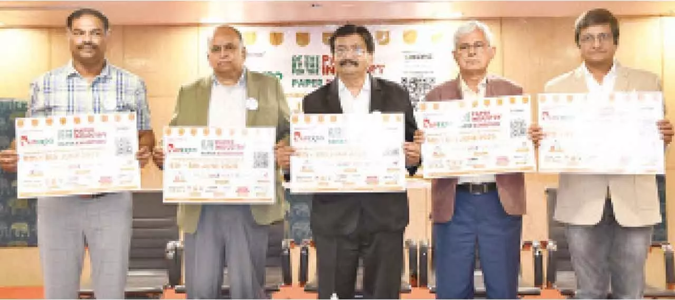
HIGHLIGHTS PAPEXPO 2025 to spotlight India’s rise as a global sustainable paper hub
Hyderabad: India is set to witness its first dedicated national exhibition for the paper industry—PAPEXPO 2025—taking place from June 6 to 8 at HITEX Exhibition Centre, Hyderabad. Organised by the Paper Foundation, the three-day mega event will bring together over 100 national and international exhibitors, showcasing cutting-edge innovations in paper manufacturing, sustainable packaging, recycling, and printing.
Supported by premier industry bodies such as the Indian Institute of Packaging (IIP), IPPTA, and FPTA, PAPEXPO is expected to attract over 15,000 visitors, including key decision-makers from paper mills, trading houses, publishers, packaging companies, and tech providers. The exhibition will be inaugurated on June 6 at 10:00 AM by dignitaries including Dr Ajay Satia (MD, Satia Industries), Soumyajit Mukherjee (CMO, Emami Paper Mills), and Dr Suresh Kumar Singhal (President, FTCCI).
The press conference announcing PAPEXPO 2025 was addressed by Nirmal Kuhad, Arvind Sharma, B R Rao, Dayaker Reddy, and Moolchand Parekh in Hyderabad on Wednesday.
Notable participants include top manufacturers such as Emami Paper, West Coast Paper, Satia Industries, Three M Paper Boards, and traders like Tirumala Balaji Paper Pvt. Ltd. and Sona Papers, further solidifying PAPEXPO’s reputation as a must-attend event for stakeholders across the paper value chain.
https://www.thehansindia.com/business/indias-1st-natl-paper-expo-in-hyd-from-june-6-to-8-975091

